**A. Timesheet Guide**

1.connect to sphere

https://circle.coresolutions.com/tcsr/Default.aspx

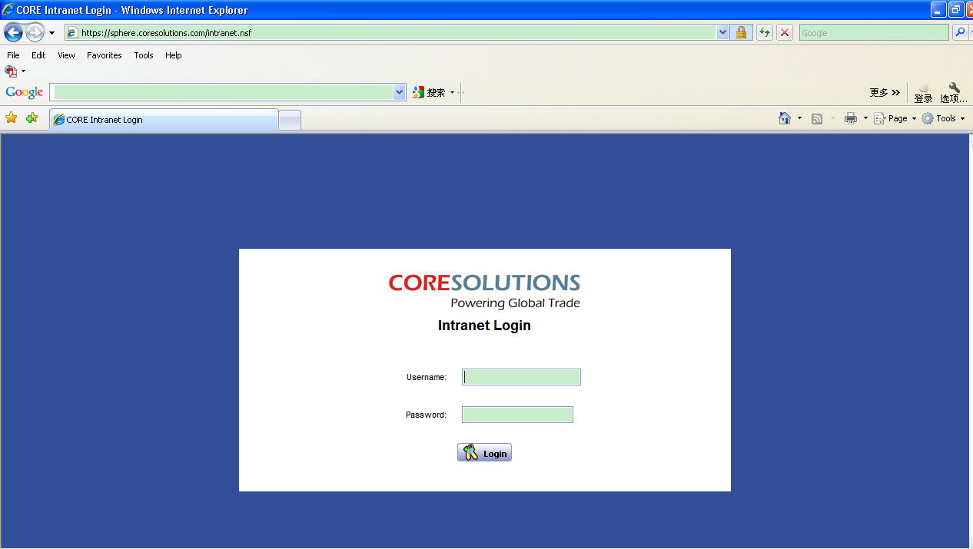

2. click TCSR

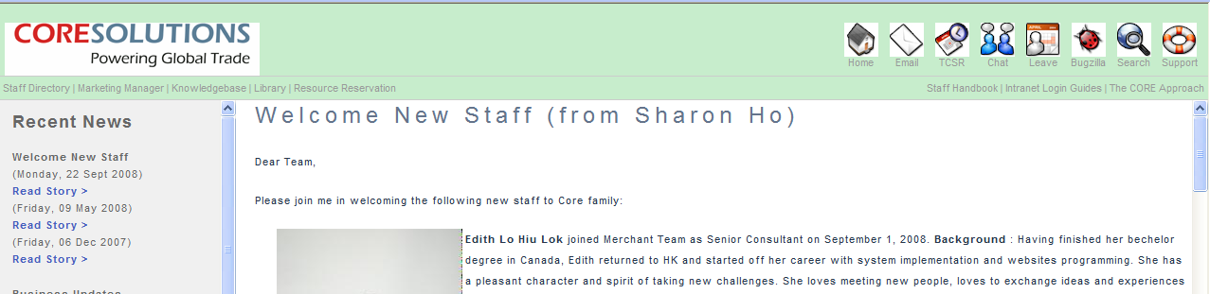

3.use your email user name and password to login

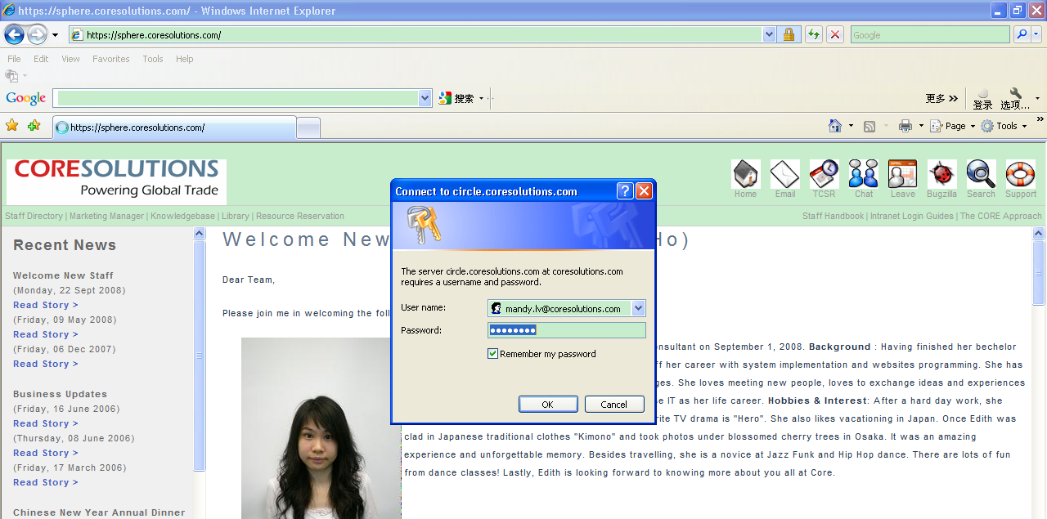

4.choose “Time-timesheet manager”

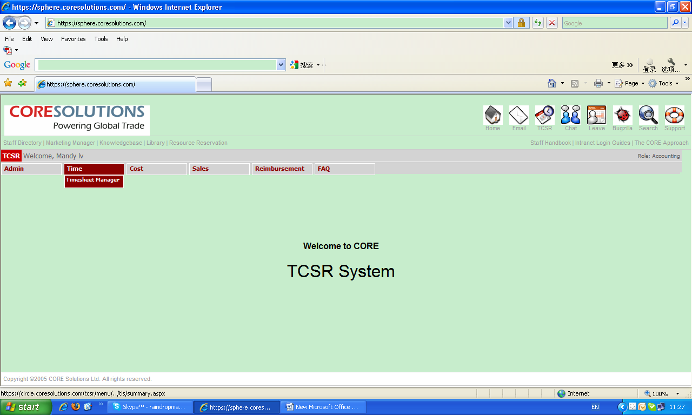

5.click “creat new”

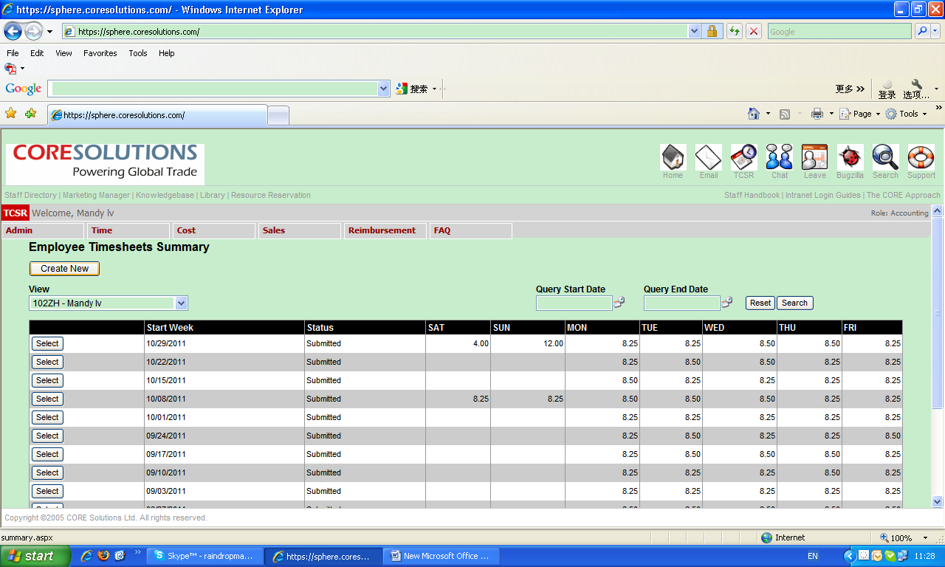

6.check the week period, and click “select” on the left

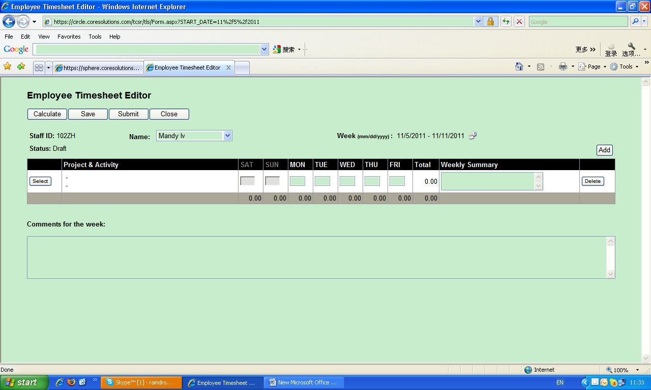

7.choose the right code of your job and should find the subdirectory code

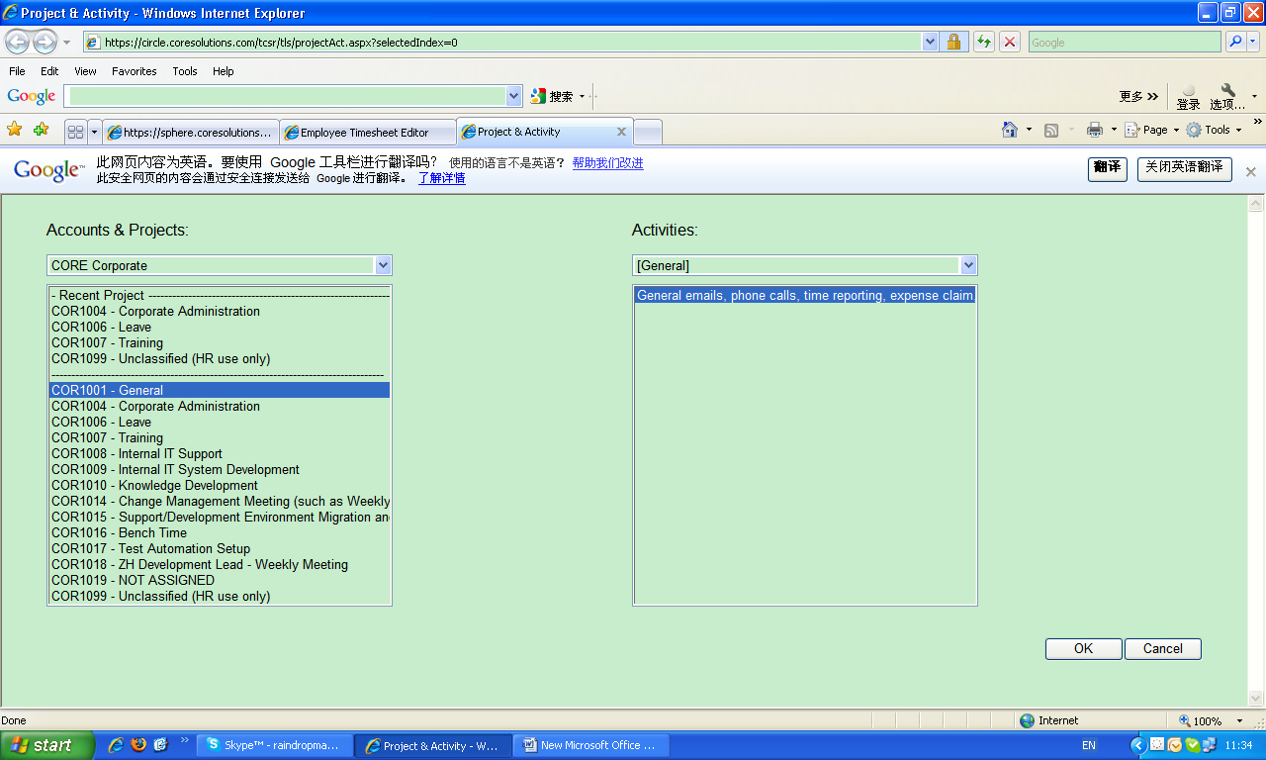

8.click OK

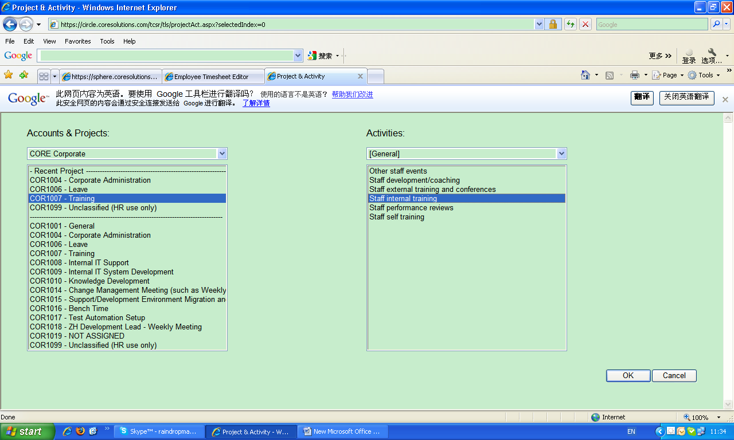

9. give a description of your job in the “weekly summary”

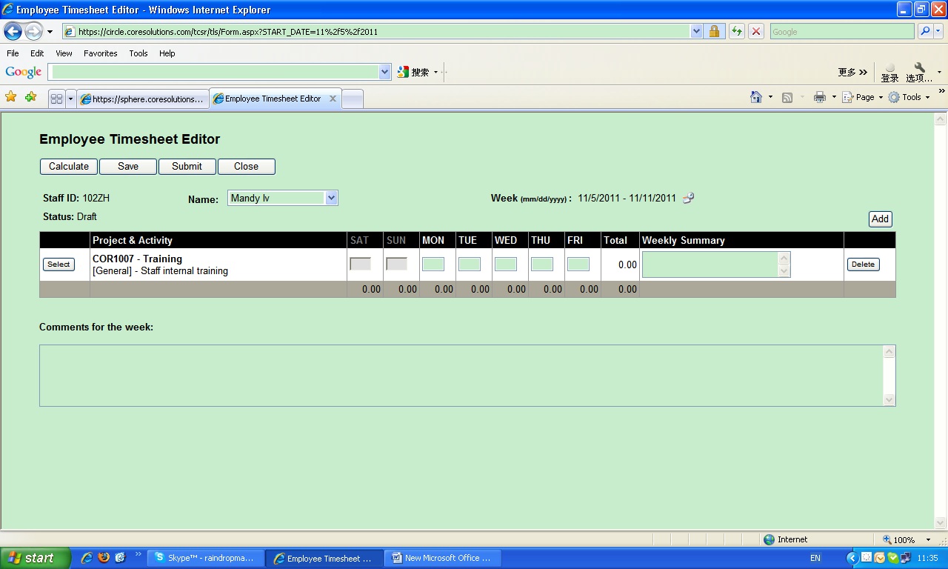

10. click “add” on the right to add more items.

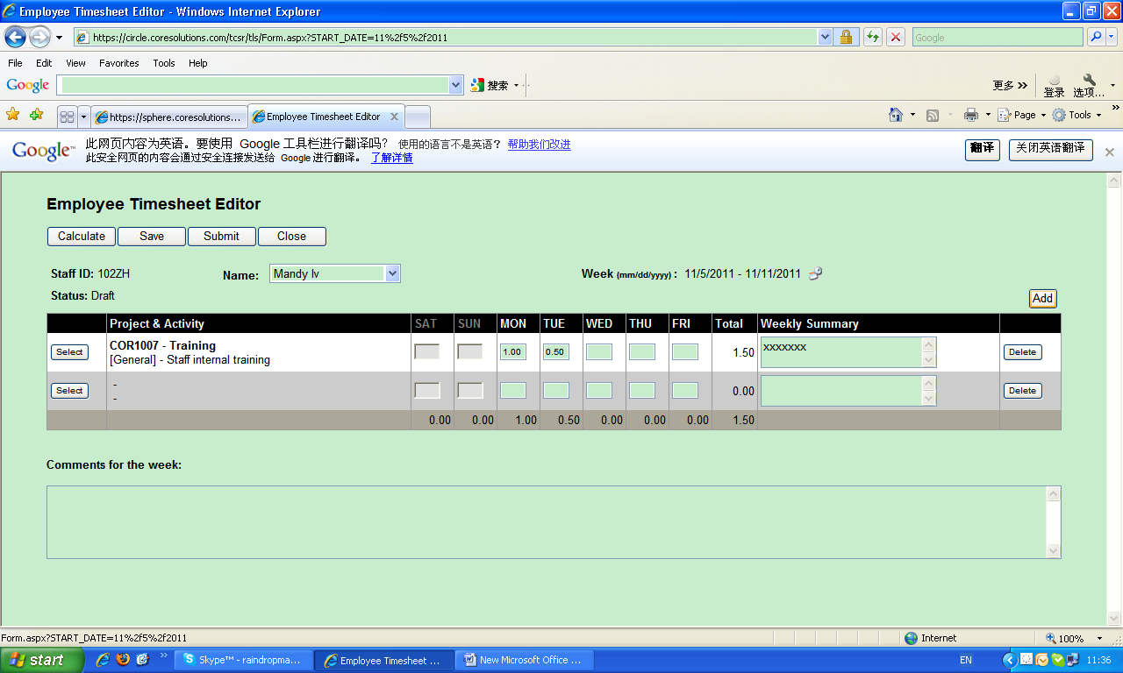

11.caculate how many hours do you take to do your job on “SAT” to “FRI”

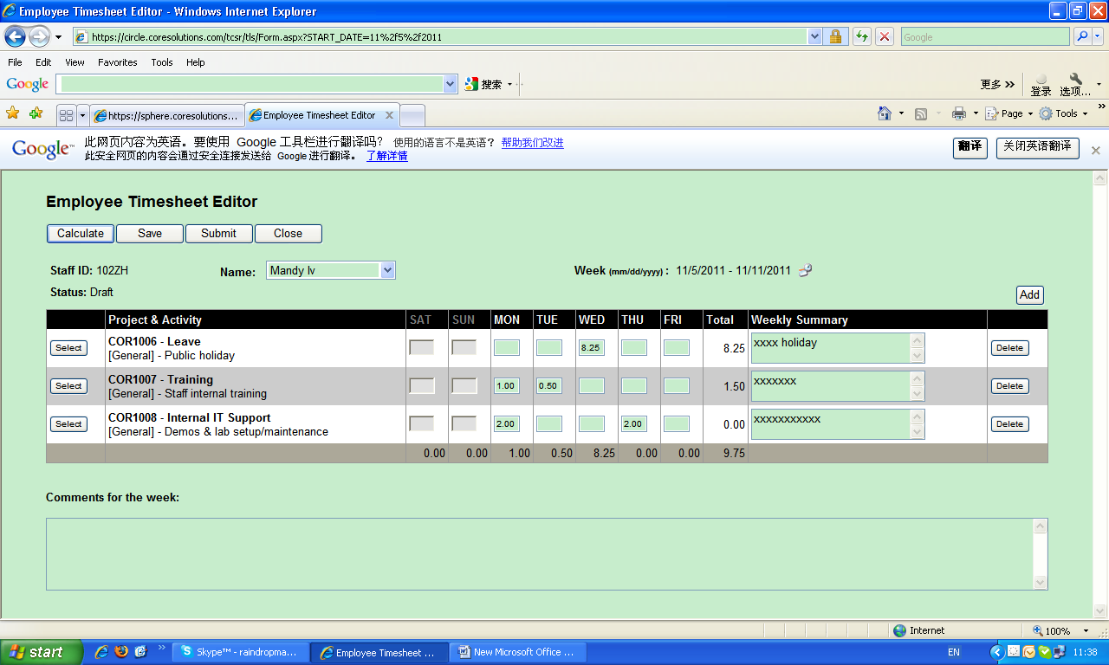

12.click “calculate” or “save” to see how many hours do you work one day. Please note that there must be more than 8.25 hours one day and more than 41.25 one week, then can submit the timesheet.

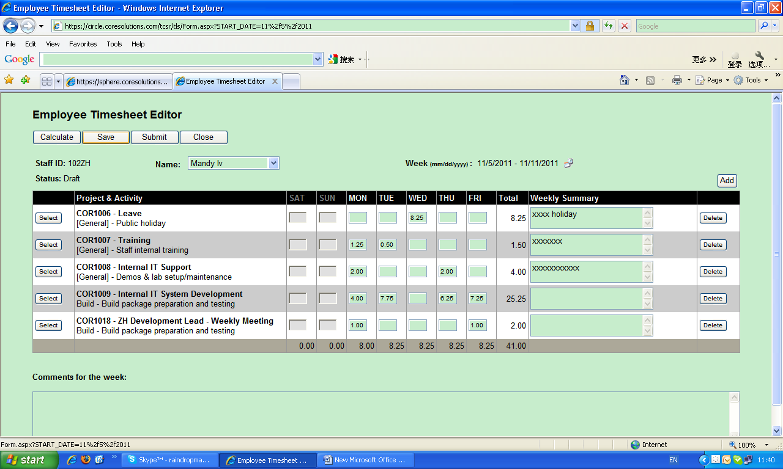

13. you can check and save timesheet as draft before submit it.

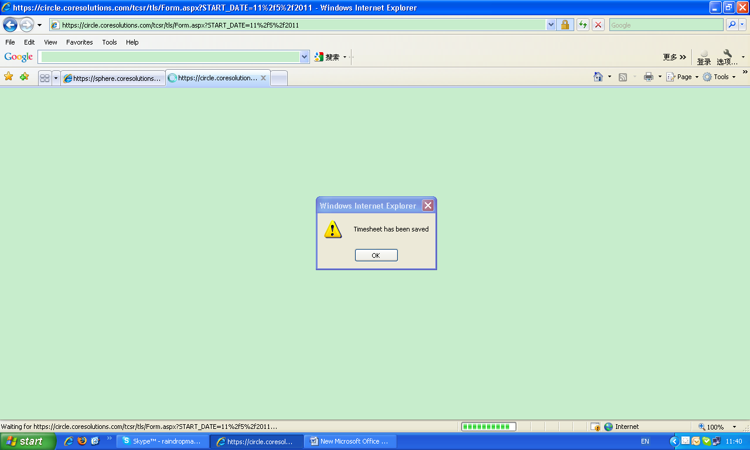

14. when you finish and have checked it, then click “submit”. Please note that, after submitted, you can not revise it, so please make sure you have check it before submit. And if you did make mistake of your timesheet, please contact Mandy or AMG to delete it and do it again.

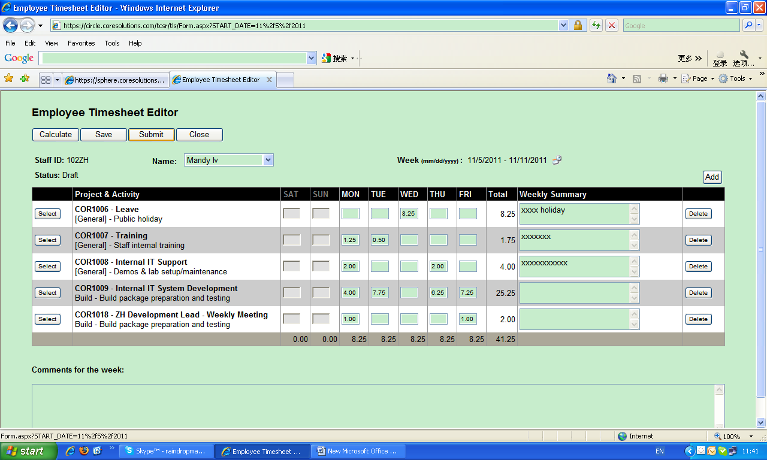

**A. Leave System Guide**

1. 1.connect to sphere



2.click “Leave”



3.

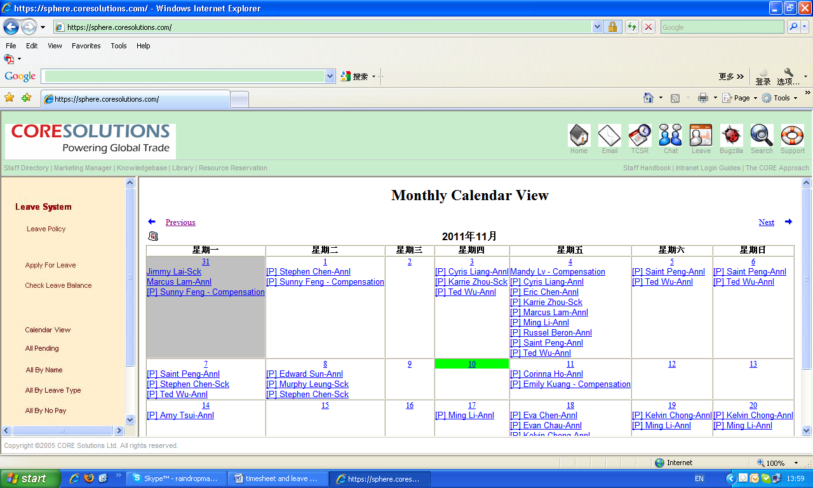

4.click “Apply for leave” on the left

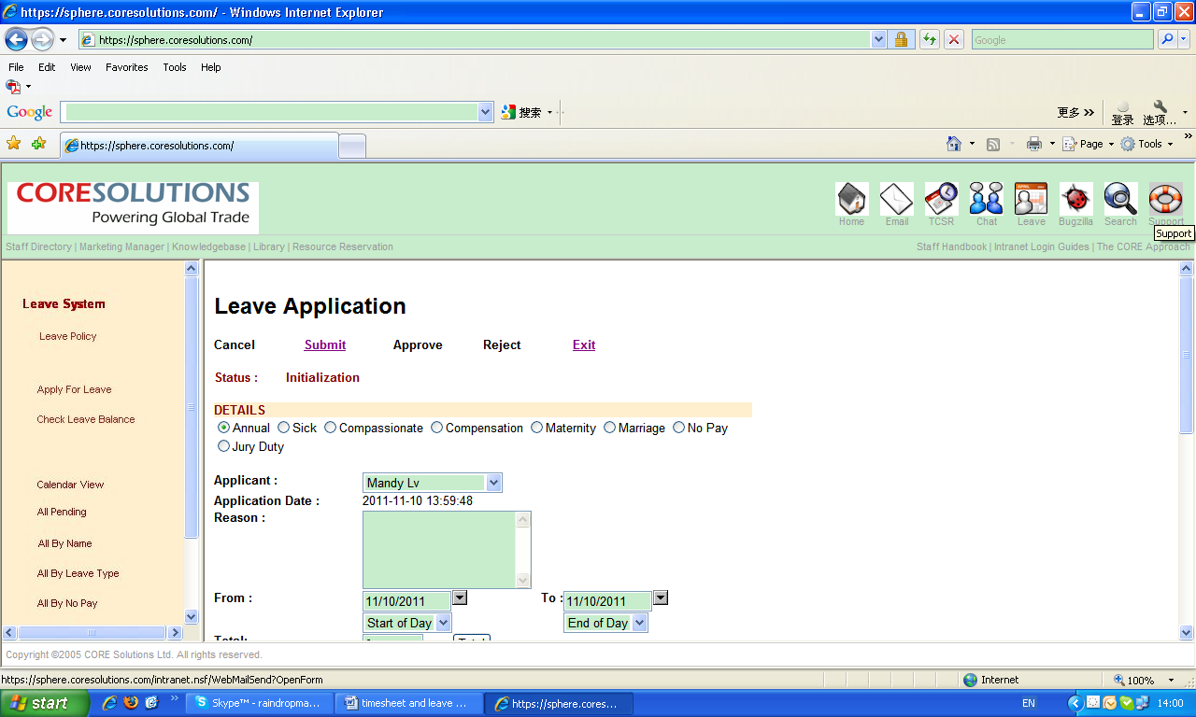

5.choose right type of leave on “DETAILS”

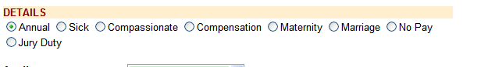

6.fill the reason of leave, apply leave date; total days

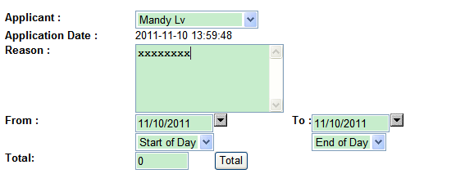

7.choose the approver and director correctly

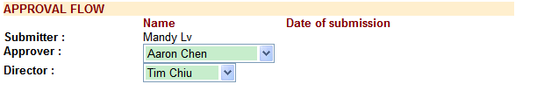

8.please check carefully before submit.



9.you can check how many holiday you have from “Check Leave Balance”

